Data Bases CE2
N1
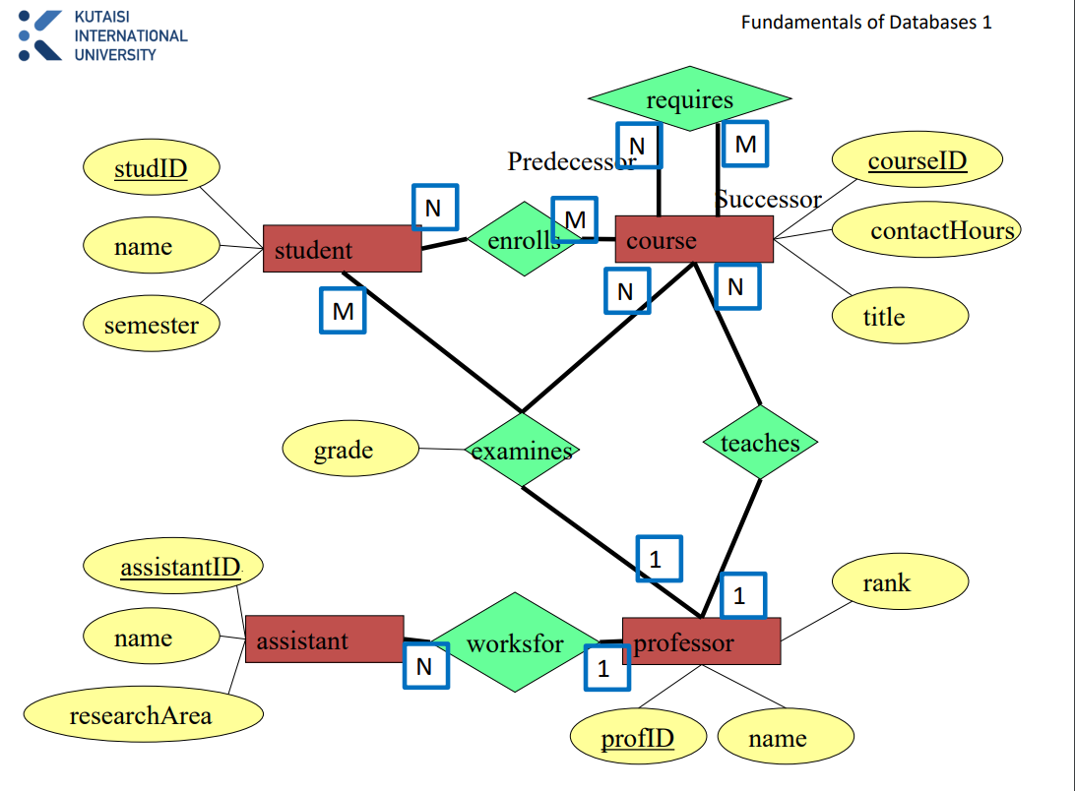
Student = {[studID: int; studName: string; semester:int]}
Course = {[ CourseID: int; contactHours: time; title: string; profID: int]}
Assistant = {[ assistantID: int; assistantName: string; researchArea: string; profID: int]}
Professor = {[profID: int; profName: string; rank: string]}
Enrollment = {[studID: int; courseID: int]}
Requirement = {[ preCourse: int; successor: int]}
Examination = {[ studID: int; courseID: int; profID: int; grade: char]}

- There are 7 final relations.
N2
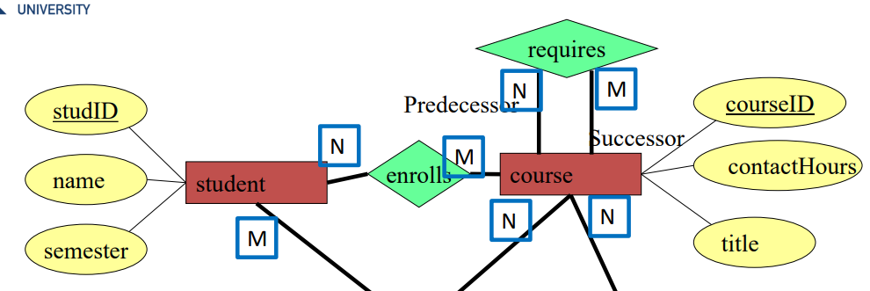

Retake = {[ studID: int; courseID: int; ]}

N3
player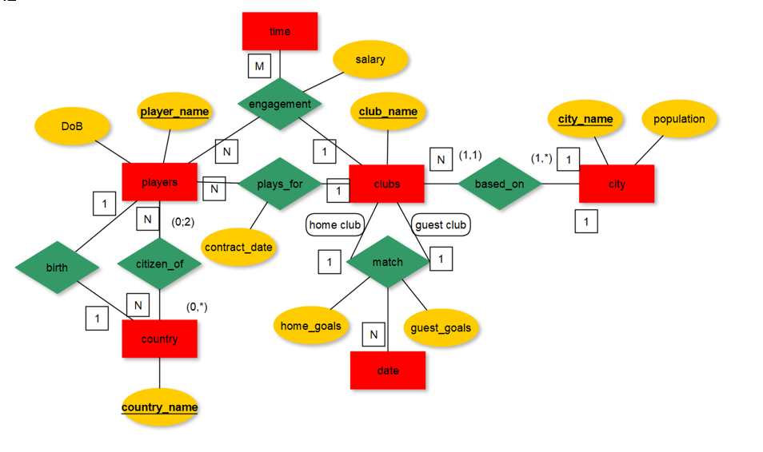
player = {[playerName: string; DoB: date; clubName: string; contractDate: date; countryName: string]}
clubs = {[clubName: string; cityName: string]}
match = {[ homeClub: string; guestClub: string; date: date; homeGoals: int; guestGoals: int]}
unique constraint: homeClub: string; date: date
city = {[cityName: string; population: int]}
country ={[countryName: string;]}
citizen_of = {[playerName: string; countryName: string]}
engagement = {[playerName: string; time: date; clubName: string; salary: decimal]}

N4.
